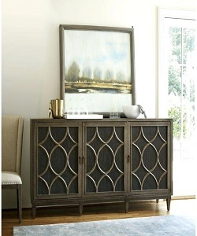

Dressing Table

$104.57

Availability: In stock

**Description:**

Take a seat in front of this black vanity table and Prepare fot the day. Its ravishing appearance will prove to be the perfect addition to your living. Although it looks very humble, how many women are captured their heart. Crafted with 3 drawers, includes space to store needed things.